Explanations about the paradoxical gears

This gear pair has been invented by Mr MERCIER of Renault automobile company, and has been patented in 1988; it was to be used in a special differential providing “torque transfer”.

We must come back to the involute theory: look at photo3 ( it is an acrylic model I have made, to use for over head projection with my students). This model shows 2 pulleys with a crossed belt (fishing line) a knot giving a point on the belt. With a felt pen, it is possible to point out the trajectory of this point on a disc locked by a pin to the left pulley (red spots) and afterward, on a disc locked to the right pulley (green spots). These spotted lines are the involute curves which will give the profile of the teeth. The pulleys are turning in opposite directions.

But look at photo4, showing a straight (non crossed) pulleys and belt mechanism, the 2 same involute curves are still meshing together, but the pulleys are now turning in the same direction! This gives the paradoxical gear pair.

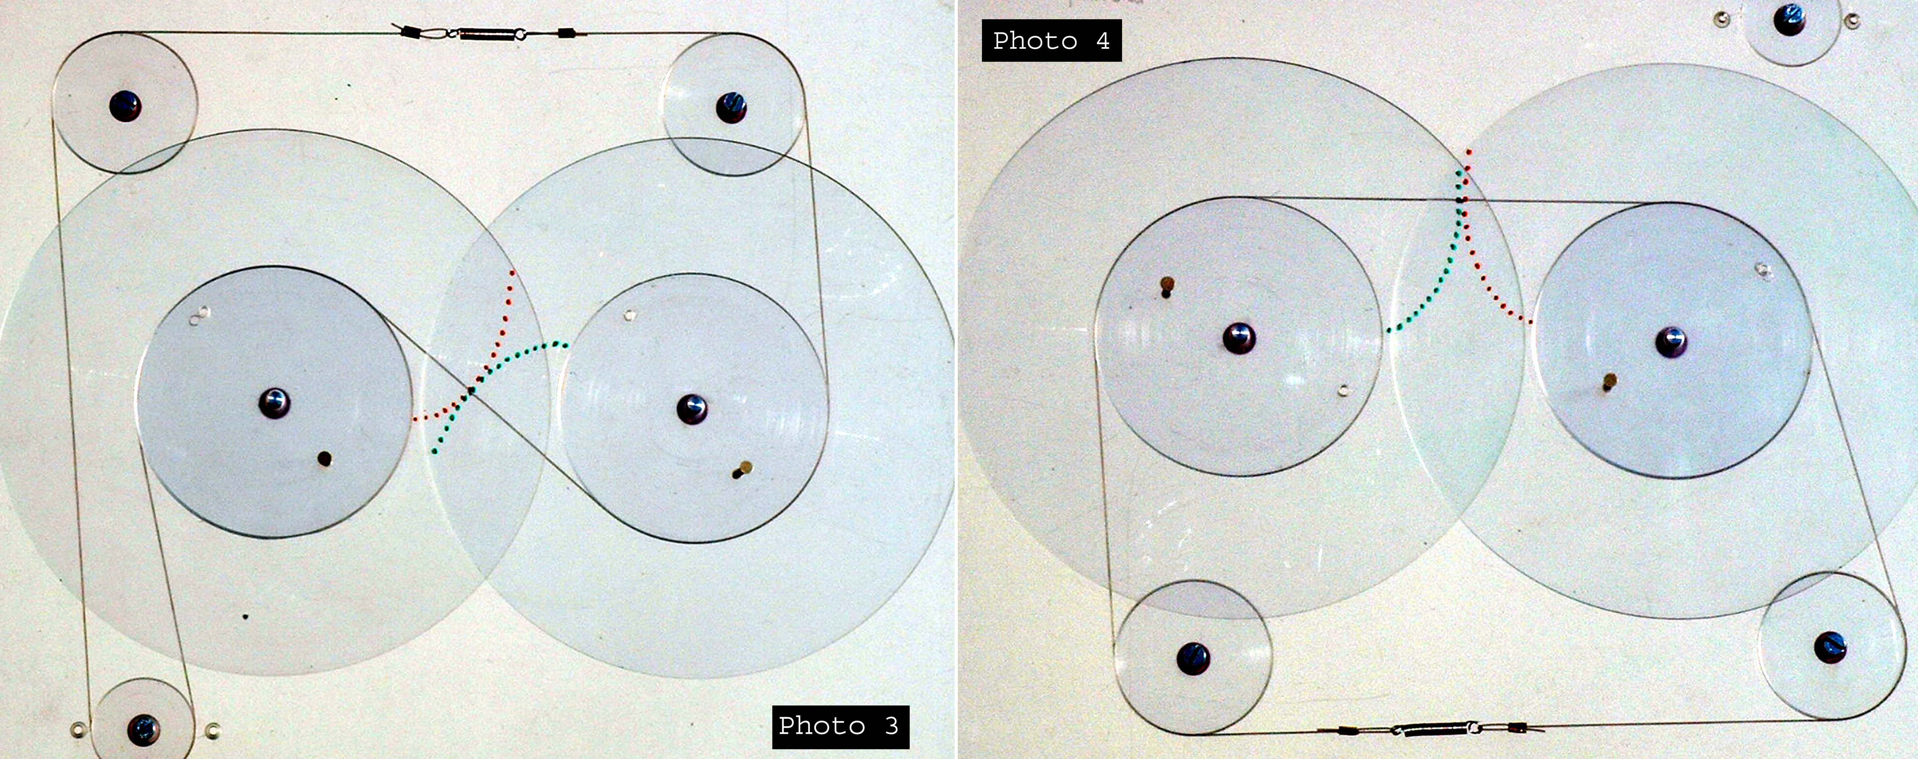

but there is still a long way from this profile to the whole gear pair.

In a standard gear pair, the tooth of one gear have the good idea to go into the slot between 2 teeth of the mating gear. This is not the case of the paradoxical gear pair, where a tooth of one gear must pass in front of the mating gear without meeting any tooth of this wheel, or locking will occur. This leads to use a very small number of teeth: 1, 2 or 3 (4 is possible but difficult) 2 teeth seem to be the optimum, and this is the number used in the “MERCIER” differential.

For a better understanding, it is possible to look at a one tooth gear pair (see photo 7). I have named this the St Valentin’s gear because of its heart shape, I have chosen to make the 2 involute curves start at the same point of the base circle, in this case, the tooth thickness (the heart width) is equal to the base circle (pulley) circumference.
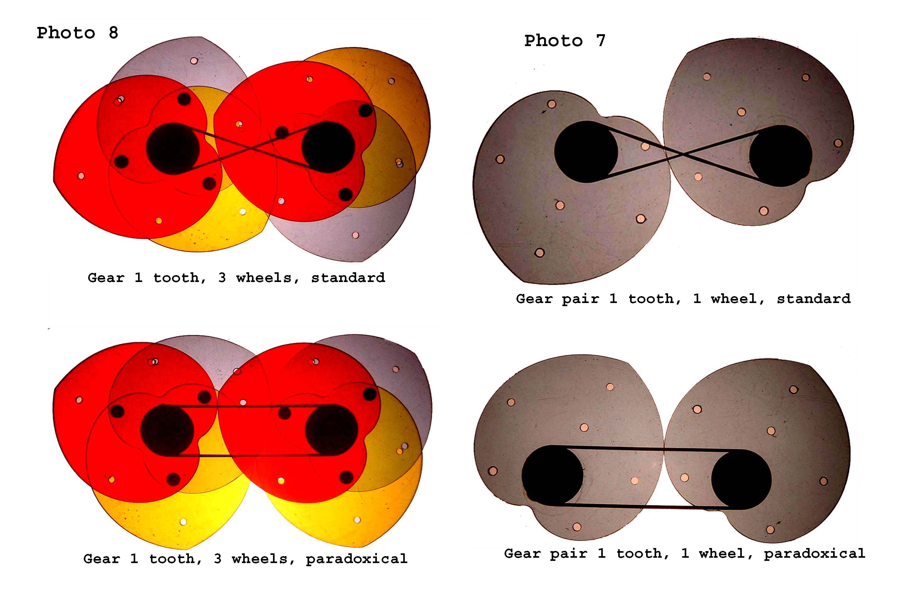

This is a very amazing gear pair, for many reasons:

As a standard gear pair: (photo 7 upside)
It is possible to see the 2 pulleys (black discs) and the rubber crossed belt which is the line of action, the left side of gear 1 (the side being at your left hand when the tooth in front of you has its apex upside) is pushing the left side of gear 2. this gear is not so standard, as the pressure angle is 70.337°, the module 94.6 mm = center distance = pitch circle diameter!
The relative movement between the gears , is a rotary motion around the point of contact of the two PCDs.

As paradoxical gear pair: (photo 7 downside)
Here the belt is straight (non crossed) and still shows the line of action, the left side of
gear 1 is now pushing the right side of gear 2. The pressure angle is 90°, and the center distance equals the tooth width = 100 mm (pulley circumference), it is impossible to define a PCD, nor a module, because the relative movement between the gears, is a circular translatory motion ( this is gear witchcraft).

Note: Translatory motion : when a straight line of a moving solid remains
parallel with its starting position . The rectilinear translatory motion is the most known.
for example, a circular translatory motion is the movement of the rod linking 2 wheels of a steam locomotive, seen from the locomotive body.

I have chosen to make a one tooth gear pair, as in these conditions it is necessary to pile up only 3 wheels to get a continuous motion (see photo 8) and so, it is possible to make an acrylic model which can be projected ( projection is impossible if a too great thickness).

Explanations about the Mercier differential

With a standard differential (see drawing 2) when there is a small adhering torque on one wheel (linked to a sun gear)the tyre being on ice for example, there will be the same torque on the other wheel (linked to the other sun gear) even if the tyre has here a good adherence, and so the car isn’t able to move (the low adhering wheel will slip and turn twice the rotary motion of the planet carrier, the other wheel being stopped). Many solutions have been invented to solve this problem, one of the best mechanical solution (without electronics)is the ” torque transfer”.
The idea is to use, inside the differential, a low efficiency gearing between the 2 wheels, so, if a wheel has a low torque adherence, a good torque will remain on the other, to move the car.
The most well known of these differentials is the “TORSEN” (see drawing 3) where the low efficiency is given by crossed axis helical gears, but its kinematics is rather complicated. It has been patented by Mr GLEASMAN in 1958, TORSEN meaning :”torque sensing”. The “MERCIER” differential
(see drawing 4) gives a very simple solution using a 2 teeth paradoxical gear pair, the efficiency of such a gear pair is low, because there is much slipping at the tooth contact.
